Aadhaar copies of all applicants associated with the proposed project are enclosed herewith.

All documents have been self-attested by the respective applicants to confirm their authenticity.

Order of submission:
1.Shaik Abdul Razak – Lead Applicant

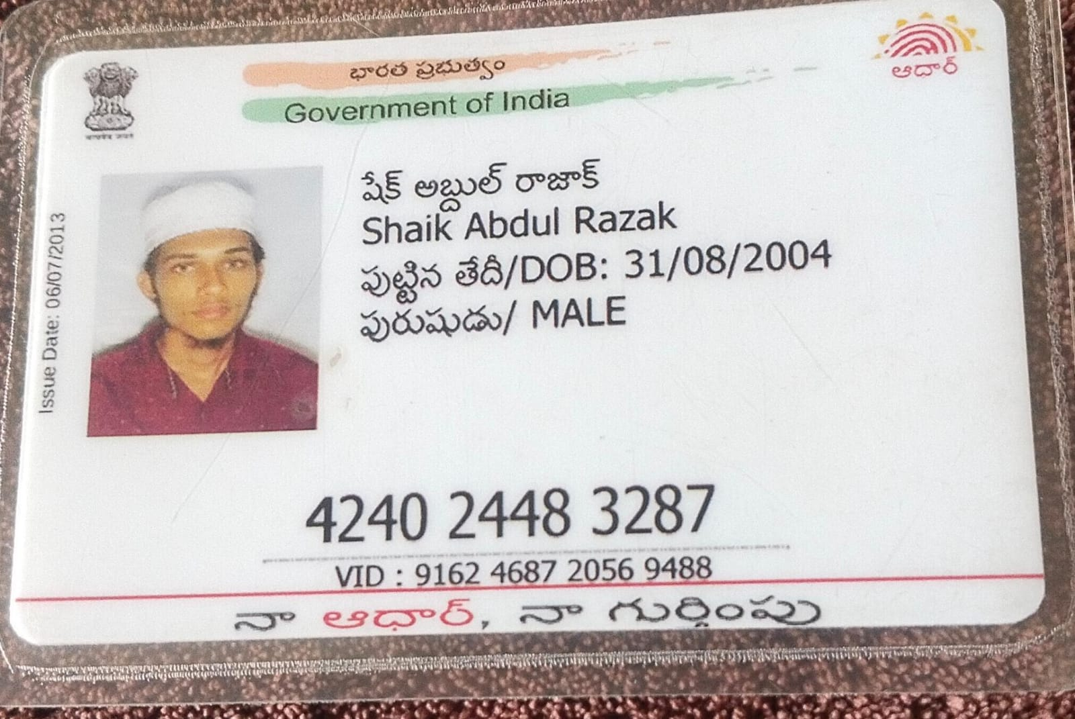

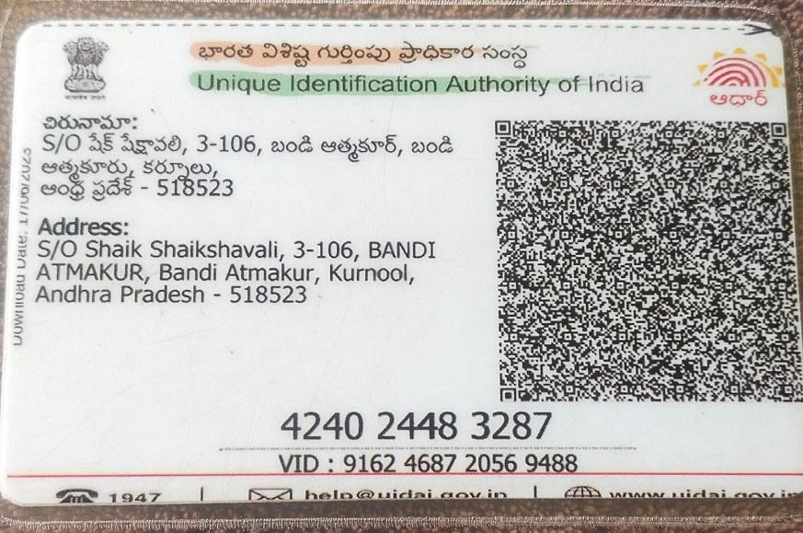

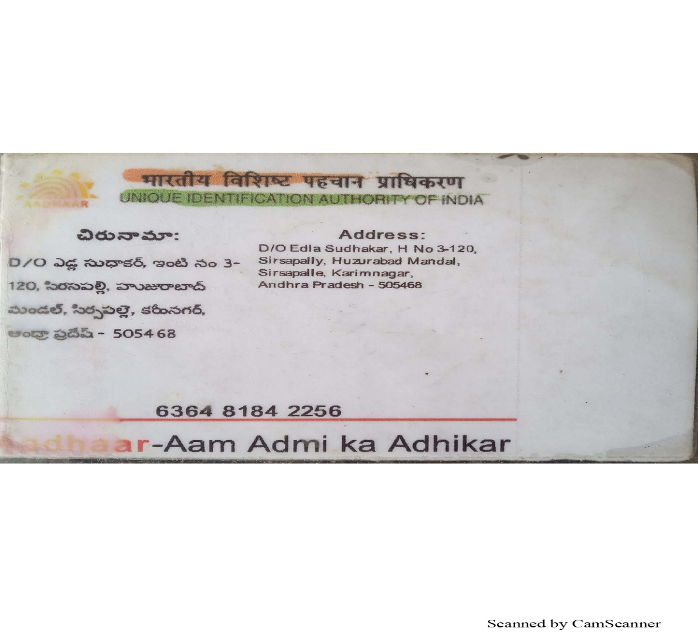
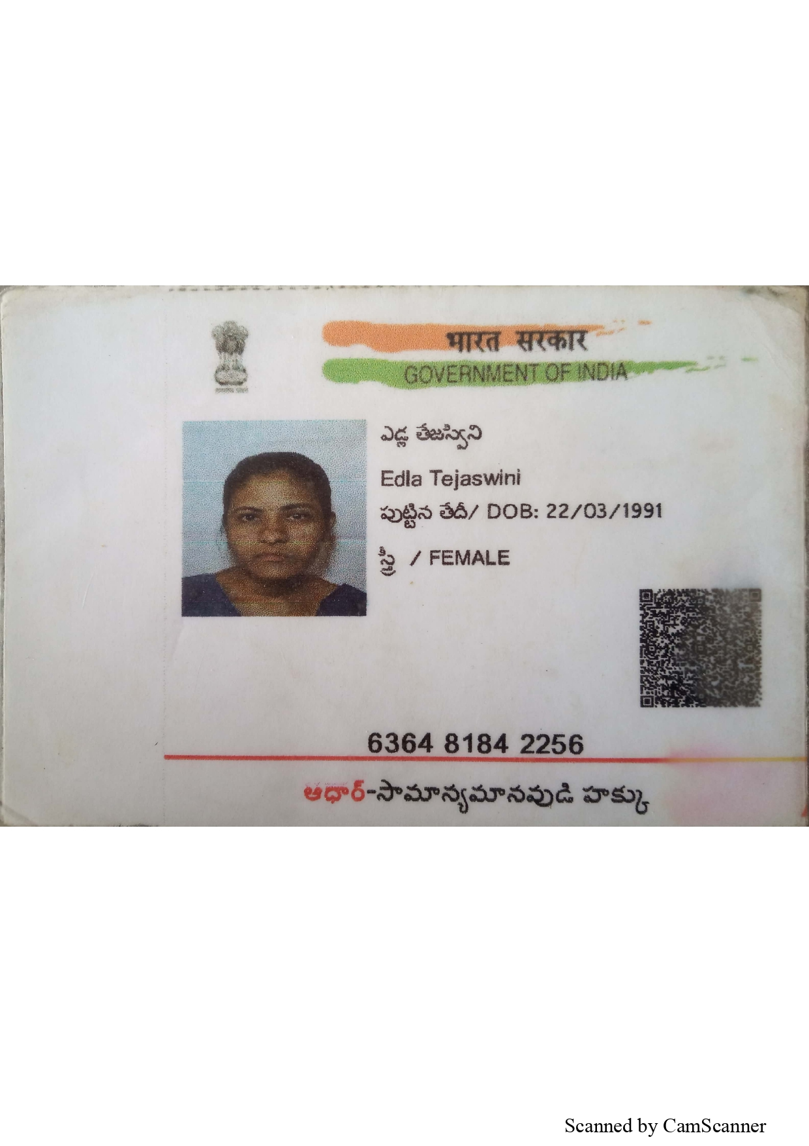
2. E. Tejaswini – Co-Applicant
3.Ramagii Praveen Kumar
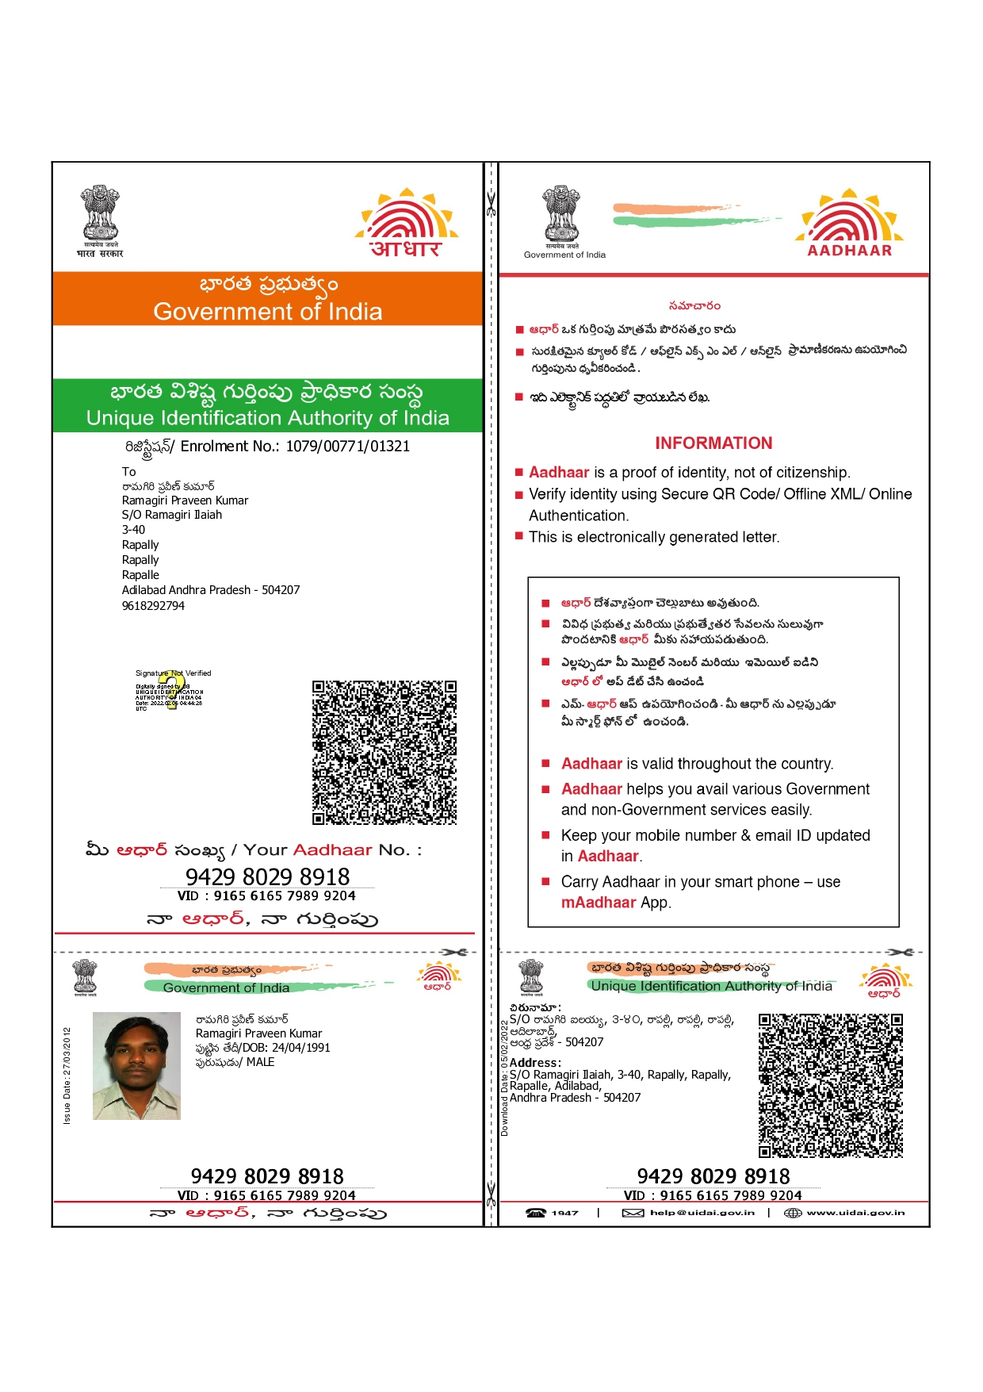
This document is submitted as per the guidelines of Nutrihub, ICAR-IIMR.

